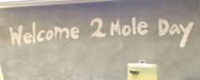

October 2008

Kudos to the Chemistry Club and the rest of the student participants for a spectacular job on the 7th Annual Student Demonstration Show!!! And thanks for making Mole Day an event to remember. ☺
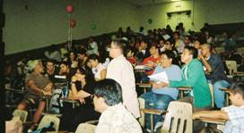
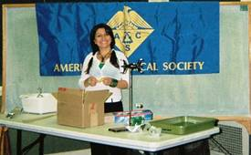

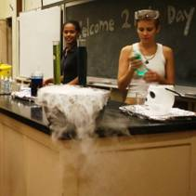
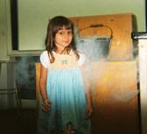
Valentina, Jae, M, &C were just a few of the club members who helped start the event off by assisting the audience and preparing the demonstrations. They even encouraged our littler audience participants to “experience” some of the chemical wonders before the show.

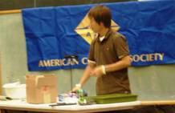
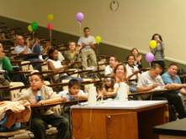
Jae & Valentine are setting up their demonstration on charge & electrostatic forces, while M & C are enticing the audience with a little dry ice in water.

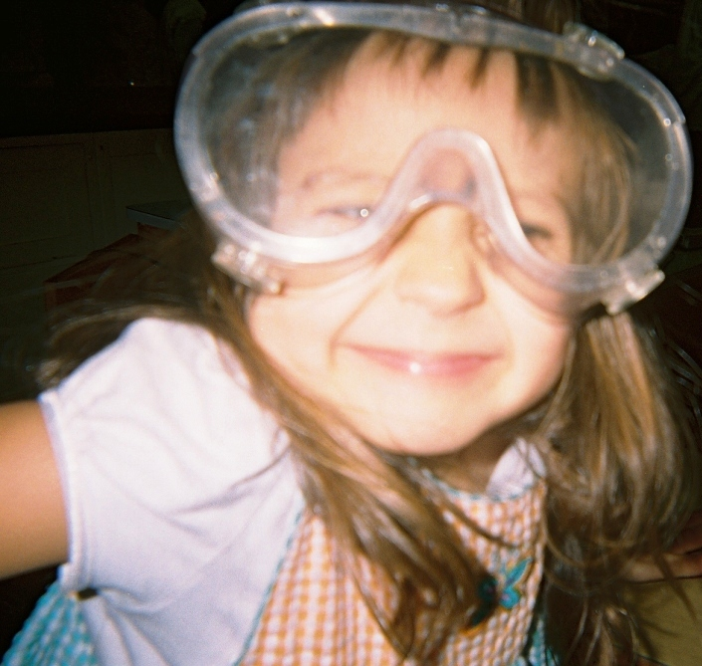

Oh and don’t forget, EVERYONE needs to wear their goggles.

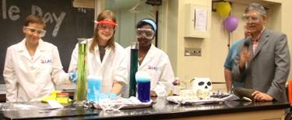
Our MC (Dr. Freid) introduces the first event! These girls like nothing better than creating a mess! The Elephant’s toothpaste demonstration (the chemistry of soap & detergents) & Dry Ice in acid-base indicators are about as spooky as it gets. BOO!

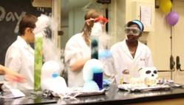

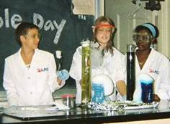
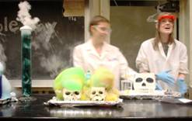

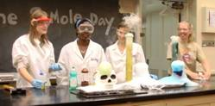

11
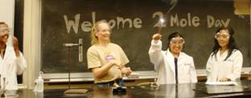
Watch the color of the solution in the center beaker in the three pictures below. The Nassau Rx is presto magic!

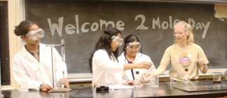
2222 2
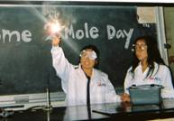

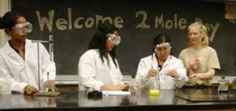
33323333 3

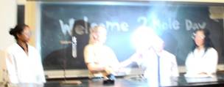

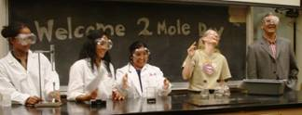
HEY! We told you not to look directly into the light! All kidding aside, magnesium metal is a great way to spark the day.

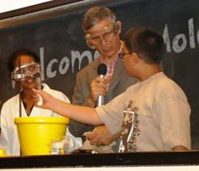
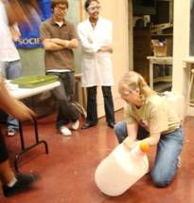
To the left, an audience participant verifies the heat produced from the disturbed supersaturated solution.

To the right, the half-time show uses an Ethanol Cannon to awaken the audience. BOOM!

You start with a racquet ball & some liquid nitrogen, put the two together, throw it on the floor AND instant mess! These men know how to “rip” a rubber ball apart. Just ask presenters Dr. Shin, Jae, & Walli.

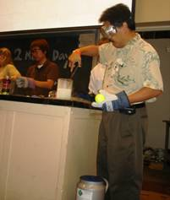
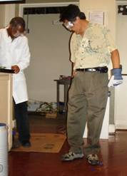
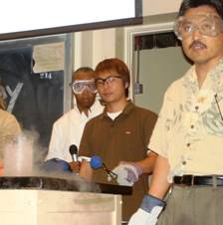

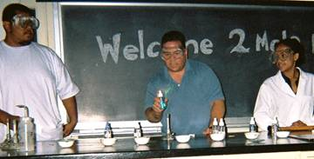
Here are a couple of guys who don’t mind burning money*… AND YET you can’t hold it against them after watching the colorful display of lights from the flame test!

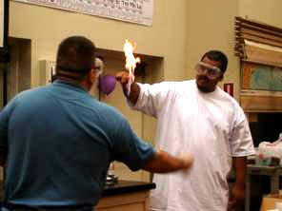

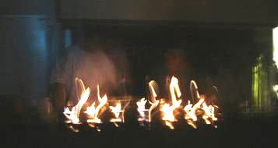

*No money was harmed in the filming of this demonstration.
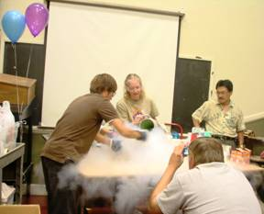
ICE CREAM!!!!
ICE CREAM!!!!

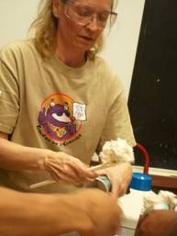
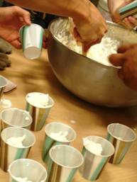

Walli, our club president, ends the show with words of encouragement and a great explosion!

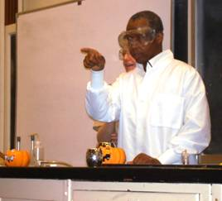

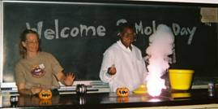
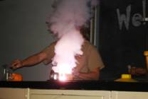

The Chemistry Club ends another engaging Mole Day with the singing of the ELEMENT SONG!
You really had to be there.

