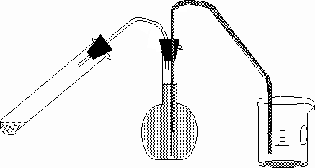

SET UP FOR EXPERIMENT 6, Analysis of an Al-Zn alloy

